**Python Mini Project Report**

**Name:** Rohan Jayaram Bhardwaj

**USN:** 22BTRSN044

**Sem / Sec:** Second semester/Software Engineering-A

**Github Link:**

**Blogger:** https://rohanjb.blogspot.com/2023/07/python-mini-project.html

**Abstract**

*Python Roulette is a straightforward and engaging Russian roulette game implemented in Python programming language. This text-based mini-project aims to provide users with a simulated experience of the classic Russian roulette challenge, without any actual risks or harm involved.*

*Python Roulette, players interact with the game through a terminal interface. The game follows the standard rules of Russian roulette, where a revolver with six chambers, one of which is loaded, is represented digitally. Players take turns pulling the trigger by pressing a specified key(1-6), with the outcome determined by a random number generator.*

1. **Problem Statement**

Create a Python program to simulate a text-based game inspired by Russian roulette. The game should feature a revolver with six chambers, one of which is loaded. Players will take turns pulling the trigger by typing 'pull' and pressing Enter. The game should randomly determine if the player survives (empty chamber) or meets their demise (loaded chamber). The objective is to see how long the player can survive before encountering the loaded chamber. The simulation must be purely fictional and avoid any promotion or glorification of dangerous activities.

1. **Methodology**

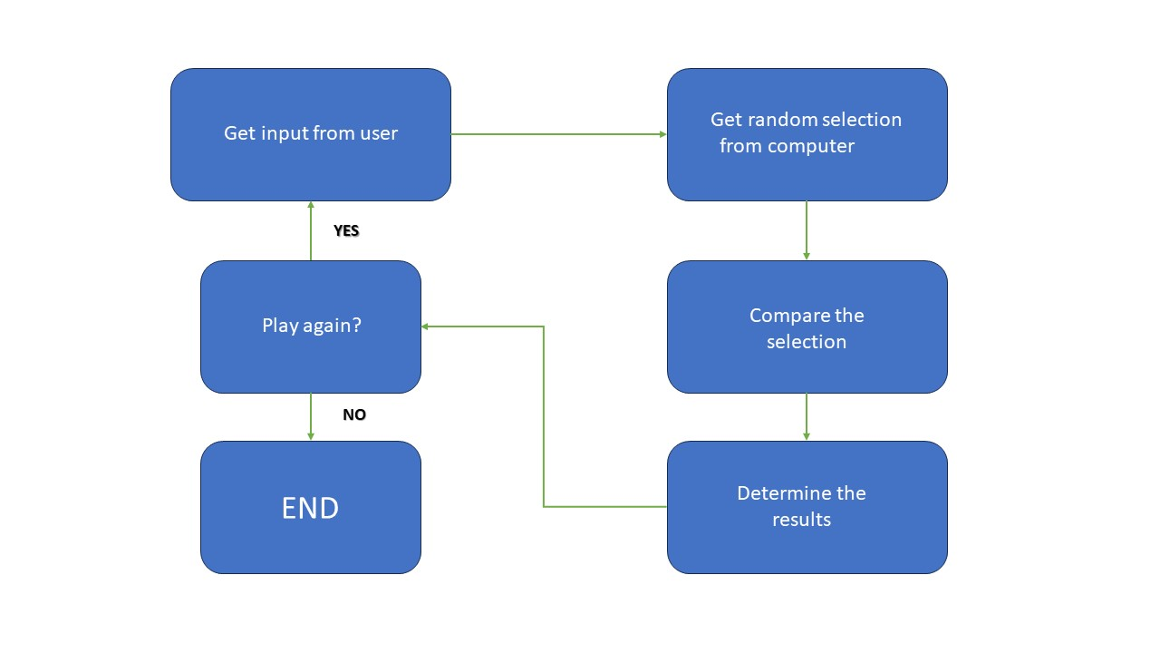

1. **Coding and Results (Snapshot)**

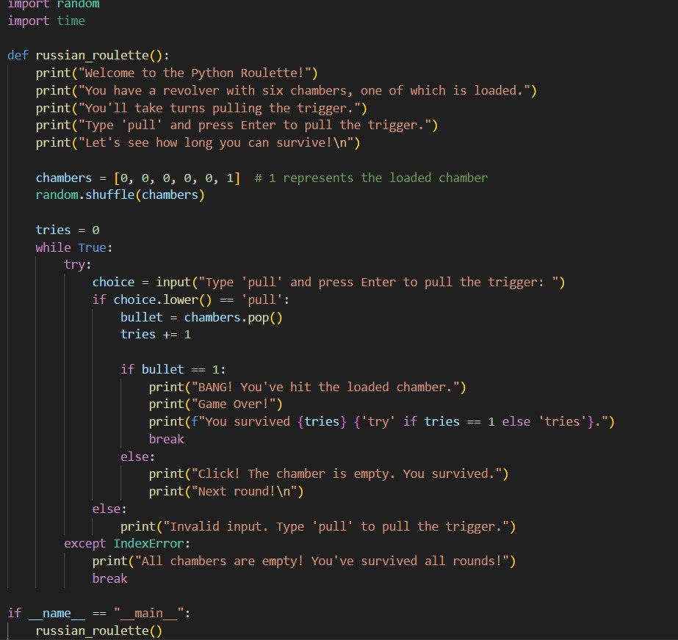

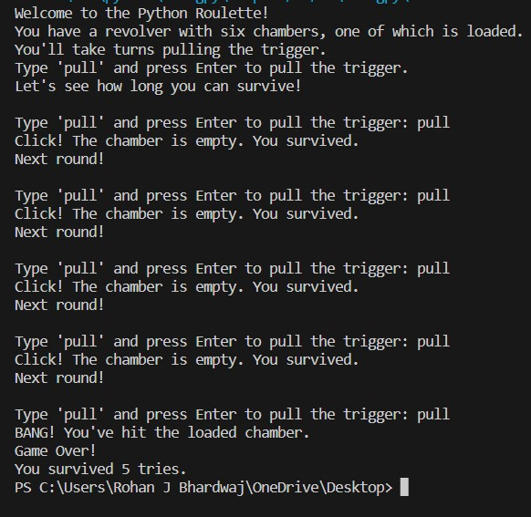

1. **Conclusion**

In conclusion, the Python program successfully implements a text-based game inspired by the concept of Russian roulette while prioritizing user safety and well-being. The game offers an engaging experience, allowing players to test their luck and see how long they can survive the simulated revolver rounds. The program demonstrates the use of randomization and exception handling to create suspense and provide a smooth gameplay experience.